Problem Formulation

Business Problem Definition:
The bank is experiencing customer churn, meaning customers are closing their accounts and leaving. This leads to lost revenue, increased customer acquisition costs, and a potential decline in market share. The bank needs to understand why customers are churning and develop strategies to prevent it.
Key Business Objectives:
- Reduce Customer Churn Rate: The primary objective is to decrease the percentage of customers who leave the bank within a specific timeframe.
- Improve Customer Retention: Enhance customer satisfaction and loyalty to retain existing customers.
- Identify High-Risk Customers: Develop a system to accurately predict which customers are most likely to churn.
- Optimize Marketing and Retention Efforts: Use insights from the analysis to target at-risk customers with personalized retention strategies.
- Increase Profitability: By reducing churn, the bank aims to increase overall profitability.

For Business Impact:
- Reduction in Churn Rate: Measure the percentage decrease in churn after implementing the model and retention strategies.
- Increase in Customer Retention Rate: Track the percentage of customers retained over time.
- Return on Investment (ROI) of Retention Campaigns: Assess the financial impact of retention efforts.
- Customer Lifetime Value (CLTV): Measure the long-term value of retained customers.

Key Data Sources and Their Attributes:
We have two data sources,
- csv files from Local filesystem
- csv file downloaded from Kaggle api
Attributes:
- CustomerId: Unique identifier for each customer (unused variable, as requested).
- credit_score (CreditScore): A numerical score representing the customer's creditworthiness.
- country (Geography): The customer's country of residence.
- gender (Gender): The customer's gender.
- age (Age): The customer's age.
- tenure (Tenure): The number of years the customer has been with the bank.
- balance (Balance): The customer's account balance.
- products_number (NumOfProducts): The number of bank products the customer uses.
- credit_card (HasCrCard): Whether the customer has a credit card (binary: 1 or 0).
- active_member (IsActiveMember): Whether the customer is an active member (binary: 1 or 0).
- estimated_salary (EstimatedSalary): The customer's estimated salary.
- churn (Exited): Whether the customer has churned (binary: 1 or 0).

Expected Outputs from the Pipeline:
1. Clean Datasets for Exploratory Data Analysis (EDA): In our case cleaned datasets are stored as bank_churn_processed.csv, the dataset is output of the following actions,
- Handle missing values (imputation or removal).
- Correct data inconsistencies and errors.
- Standardize data formats.
- Remove duplicate records.
- The output will be a clean, consistent dataset ready for visualization and statistical analysis.
2. Transformed Features for Machine Learning: In our case transformed data is stored in database and is retrieved by the script during model building and validation
- Encode categorical variables (e.g., one-hot encoding or label encoding).
- Scale numerical features (e.g., standardization or normalization).
- Create new features (feature engineering) that may improve model, following are the new features
Feature Name | Formula / Logic | Purpose
Customer_Tenure_Years | Tenure / 12 | Converts tenure from months to years
Activity_Frequency | Is_Active * Tenure | Weighs long-term active customers
Avg_Balance_per_Product | Balance / Num_Products (Handles division by zero) | Evaluates how much balance is distributed per product
Credit_Card_Utilization | Has_Credit_Card * Balance | Measures how much balance is used by credit card holders
Salary_Normalized | (Salary - min) / (max - min) (Min-Max Scaling) | Scales salary values for better ML performance
Spending_Power_Index | Balance / Salary | Assesses financial strength based on balance & salary
High_Value_Customer | 1 if (Balance > median & Salary > median) else 0 | Flags premium customers based on income & balance

3. A Deployable Model to Predict Customer Churn:
- Train a machine learning model (logistic regression, random forest) to predict the probability of customer churn.
- The model should be serialized and ready for deployment in a production environment.
- The output will be a trained and serialized machine learning model.
Measurable Evaluation Metrics:
For Model Performance:
- Accuracy: The overall percentage of correct predictions.
- Precision: The proportion of correctly predicted churned customers out of all customers predicted to churn.
- Recall (Sensitivity): The proportion of correctly predicted churned customers out of all actual churned customers.
- F1-Score: The harmonic mean of precision and recall, balancing both metrics.

Data Pipeline Architecture (End-to-end pipeline)
Following is the end-to-end pipeline diagram.
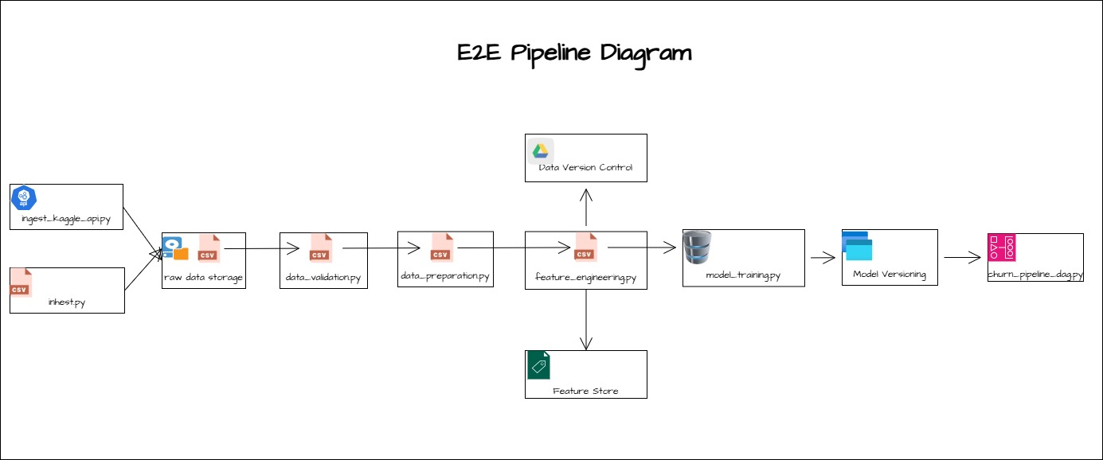

Technical overview:
1. Data Ingestion (ingest.py and ingest_kaggle_api.py)
🔹 Purpose: Extract raw data from various sources (CSV, API).
🔹 Key Methods:
- Reads CSV files into Pandas DataFrame.
- Calls an API endpoint to retrieve customer records.

2. Data Validation (data_validation.py)
🔹 Purpose: Ensure data integrity before training. Uses Great Expectations (GE) for validation.
🔹 Key Methods:
- Logs percentage of missing values per feature.
- Ensures feature data types match the expected format.
- Stores validation results in JSON format.
- Saves interactive reports for better visualization in HTML format

3. Data Preparation(data_preparation.py and eda.ipynb)
🔹 Purpose: Clean, transform, and standardize data for modeling.
🔹 Key Methods:
- Renames inconsistent column names.
- handle NaNs.
- Converts categorical features using one-hot encoding.
- Normalizes numerical features with Z-score standardization.
- Remove duplicates
🔹 Purpose: Generate statistical insights and correlations in the dataset.
🔹 Key Methods:
- Computes mean, median, and feature distributions.
- Plots heatmaps for feature relationships.

4. Data Transformation (feature_engineering.py)
🔹 Purpose: Generate new features and store it in sqlite database. Also save data in feature store (feast)
🔹 Key Methods:
- Derive new features
- Stores features in an online feature store for real-time model inference.
- Load data in sqlite database

5. Data Version Control
🔹 Purpose: Version control for transformed datasets. The versions will be maintained in google drive.

6. Model Training (model_training.py)
🔹 Purpose: Train Logistic Regression and Random Forest models.
🔹 Key Methods:
- Splits data into train-test sets.
- Uses GridSearchCV for hyperparameter tuning and train the models
- Logs accuracy, precision, recall, F1-score.

7. Model serving (model_inference.py)
🔹 Purpose: Deploy trained models as a REST API using Flask.
🔹 Key Methods:
- Loads the latest trained model from disk.
- Accepts API requests and returns churn predictions.

8. Scheduling with Airflow DAG (churn_pipeline_dag.py)
🔹 Purpose: Automates pipeline execution every 10 minutes.
🔹 Key Airflow DAG Components:
- @dag(schedule_interval="*/10 * * * *") – Triggers DAG every 10 mins.
- PythonOperator – Runs Python scripts sequentially as tasks.
- task dependencies – Ensures correct execution order
Following is the DAG
